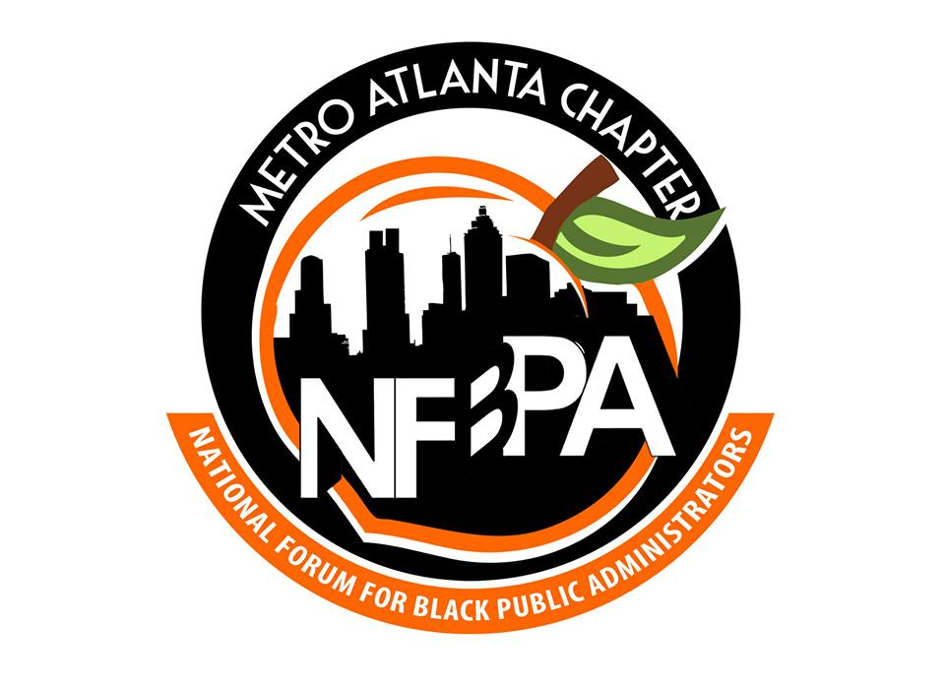
CONTACT: FOR IMMEDIATE RELEASE
Heather Fatzinger
404.210.0253

METRO ATLANTA CHAPTER OF NFBPA HONORS OUTSTANDING PUBLIC SERVANTS AT UPCOMING
LEGACY BREAKFAST

November 13, 2015 (Atlanta, GA)—The National Forum for Black Public Administrators (NFBPA) will host its first annual Legacy Breakfast on Saturday, December 12, 2015 at the Georgia Freight Depot, Blue Room, 65 Martin Luther King Jr. Dr., Atlanta, GA 30312, 8:00 am. The awards breakfast will honor five exceptional leaders who have made significant contributions in public service.

This year’s honorees include:
- Cassius Butts, Region IV Administrator, U.S. Small Business Administration
- David Hankerson, Cobb County Manager
- Katerina Taylor, President & CEO, DeKalb Chamber of Commerce
- Michael Thurmond, former Commissioner, Georgia Department of Labor, Interim Superintendent of DeKalb County School District
- Reggie White, General Manager & National Vice-President, Government and Education Segment at CIGNA Healthcare
Metro Atlanta Chapter (MAC) President, Shamiah T. Kerney, shared “NFPBA-MAC congratulates this year’s award recipients because each of them exemplifies the best in public service and the field of public administration. When we think of what it means to leave a legacy—to leave a path for others to follow and a model to emulate—these individuals deserve to be honored for their commitment and dedication in all levels of government. We are looking forward to a great event, and an opportunity to acknowledge their service.” To register for the event, visit http://maclegacy.eventbrite.com. For more information, email programs@nfbpaatlanta.com or visit www.nfbpaatlanta.com.
About NFBPA
The National Forum for Black Public Administrators (NFBPA) is one of the nation's largest organizations of public sector African American professionals. An independent, nonpartisan, 501(c)(3) nonprofit organization founded in 1983, the mission of NFBPA is to strengthen the capacity of state and local government managers and to groom and prepare younger, aspiring administrators for senior public management positions. The organization’s 2,000 members can be found managing public programs and agencies in more than 350 jurisdictions nationwide. Thirty-five chapters support the growth of the organization at the local level. For more information, please visit www.nfbpa.org.

###

